ROBOMANIPAL TASK-3 ELECTRONICS

**VARIOUS TYPES OF SENSORS**

BY : RUTUJ NAGARKAR

horizontal line

# 

# Introduction

Sensors are transducers that detect physical, chemical, or biological changes and convert them into measurable electrical signals. They form the backbone of electronics in automation, control systems, IoT, robotics, and industrial applications.

## 

## 

## 

## Proximity Sensors

They are non-contact sensors that detect the presence/absence or distance of an object. The diversity of proximity sensing is dictated by the physical energy field used for detection.

Each energy field offers unique advantages and disadvantages in terms of range, accuracy, material compatibility, and environmental resilience, thereby dictating the suitability of a particular proximity sensing technique for a given application.

There are five types of proximity sensors namely :

1. Inductive Proximity Sensor.
2. Capacitive Proximity Sensor.
3. Optical Proximity Sensor.
4. Magnetic Proximity Sensor.
5. Ultrasonic proximity Sensor.

1. INDUCTIVE PROXIMITY SENSOR

**Operation:**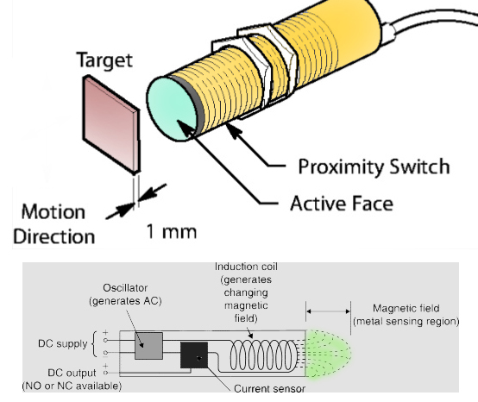

Generate an AC magnetic field using a detection coil.

Conductive metallic objects entering the field create eddy currents.

This energy absorption leads to magnetic loss in the primary field.

Sensor circuitry detects changes in the detection coil's impedance, signaling the object's presence.

**Characteristics:**

Detects only conductive metals.

Advantage: Robust and immune to non-metallic contaminants (dirt, moisture, dust).

Ideal for harsh industrial environments.

Typically provides a binary digital ON/OFF signal; some offer analog voltage proportional to distance.

**Applications:**  Metal detectors, position sensing in CNC machines.

2. CAPACITIVE PROXIMITY SENSOR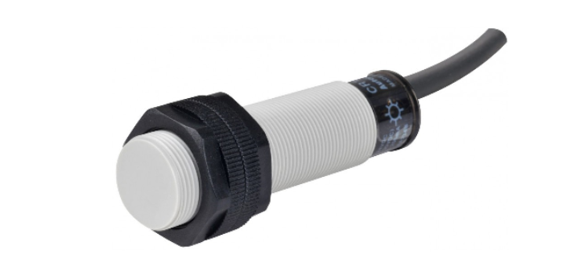

**Operation:** Capacitive proximity sensors work by detecting changes in capacitance between the sensor's active plate and a target object. They generate an electrostatic field, and the total capacitance of this field is influenced by the object's distance, size, and dielectric constant.

**Characteristics:**

**Versatile Material Detection:** Unlike inductive sensors, capacitive sensors can detect both conductive and non-conductive materials. This includes liquids, plastics, glass, and powders, as they sense changes in the material's dielectric properties.

**Environmental Sensitivity:** Due to their reliance on dielectric properties, they can be susceptible to environmental variations like humidity or contaminants (e.g., water films), which can impact the stability of measurements.

**Output Types:** Their output can be either a digital switching signal (indicating presence or absence) or an analog signal, where the signal strength is proportional to the change in capacitance.

**Applications:**

* Level detection for liquids or powders in tanks and hoppers.
* Detection of non-metallic objects on assembly lines.
* Presence sensing for packaging applications (e.g., detecting if a cap is on a bottle).
* Thickness measurement of non-conductive materials.
* Object counting in environments where metallic and non-metallic items are mixed.

3. OPTICAL PROXIMITY SENSOR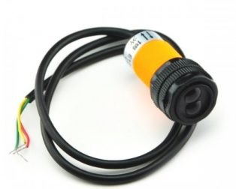

* Photo-optic proximity detection (photoelectric sensing) utilizes a light source (LED or laser diode) and a photo-detector.
* In diffuse or proximity mode, an object is detected when light from the source reflects off its surface and returns to the receiver.
* This method typically provides the quickest response time among proximity technologies.
* Its performance is significantly affected by the target's color and reflectivity.
* The output is almost always a rapid digital switch signal.

4. MAGNETIC PROXIMITY SENSOR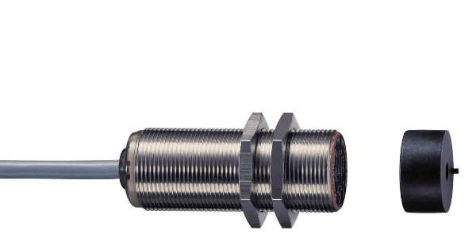

* **Working Principle:**

This sensor operates on a mechanical principle, exclusively detecting magnetic fields, such as those produced by permanent magnets. It identifies the presence of a magnetic object, known as the target. When the target's magnetic field enters the sensor's detection range, it initiates the switching process.

* **Applications:** Security door locks, speedometers.

5. ULTRASONIC PROXIMITY SENSOR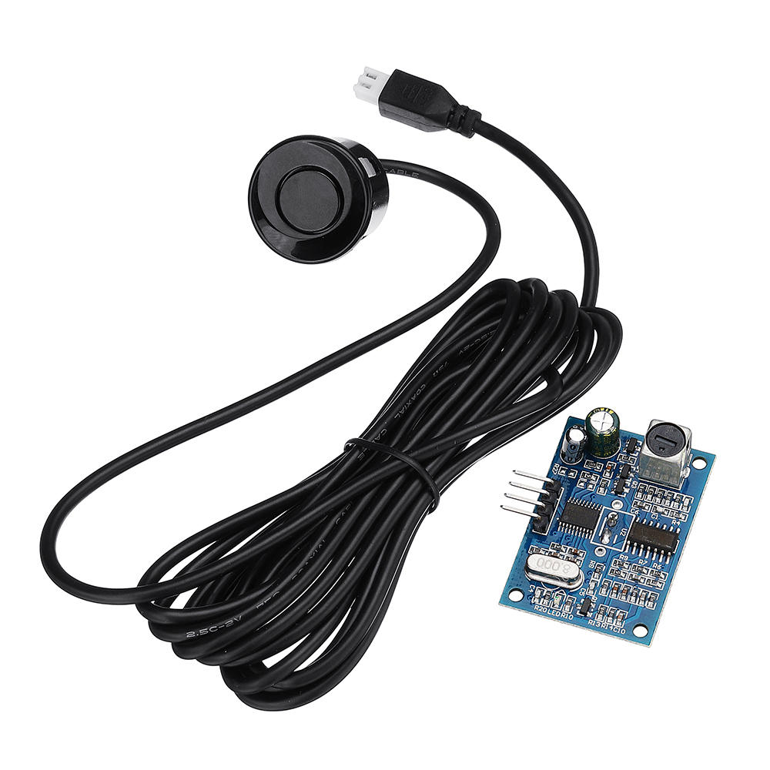

Ultrasonic sensors determine an object's distance by emitting high-frequency sound waves and measuring the time it takes for the echo to return. These sensors are not influenced by an object's color or transparency.

**Applications:**Robotic obstacle avoidance, Tank level measurement, Presence detection for security

## Colour Sensor

Color sensors, such as the TCS3200, identify an object's color. They typically employ an array of photodiodes, each fitted with a different color filter (red, green, or blue). By measuring the light intensity for each of these colors, the sensor can determine the object's reflected color. Some sensors also include a clear filter to measure overall light intensity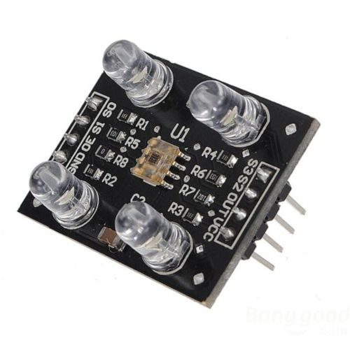

**Applications:** Industrial sorting, agriculture (fruit ripeness), robotics line detection.

## 

## Light Dependent Resistor (LDR)

* **Function:** Detects and quantifies light intensity.
* **Principle:** Relies on **photoconductivity**.
* **Construction:** Uses a light-sensitive semiconductor (often Cadmium Sulfide) in a zig-zag pattern on an insulating substrate.
* **Mechanism:** Photons excite electrons, increasing charge carriers.
* **Output:** **Change in resistance**, **inversely proportional** to light intensity (more light = less resistance = higher current).
* **Requirement:** Needs an external conditioning circuit (e.g., voltage divider) to convert resistance changes into a usable analog voltage.
* **Advantages:** Low cost and high sensitivity.
* **Disadvantages:** Slower response compared to photodiodes.
* **Applications:** Simple automation tasks like street lights, light meters, and basic security systems.

## Hall Effect Sensor

* A Hall effect sensor is a transducer that generates an output voltage proportional to a magnetic field.
* This happens because when current flows through a conductor in a magnetic field, a voltage (Hall voltage) is produced perpendicular to both the current and the field.
* These sensors are useful for detecting proximity, position, speed, and electric current.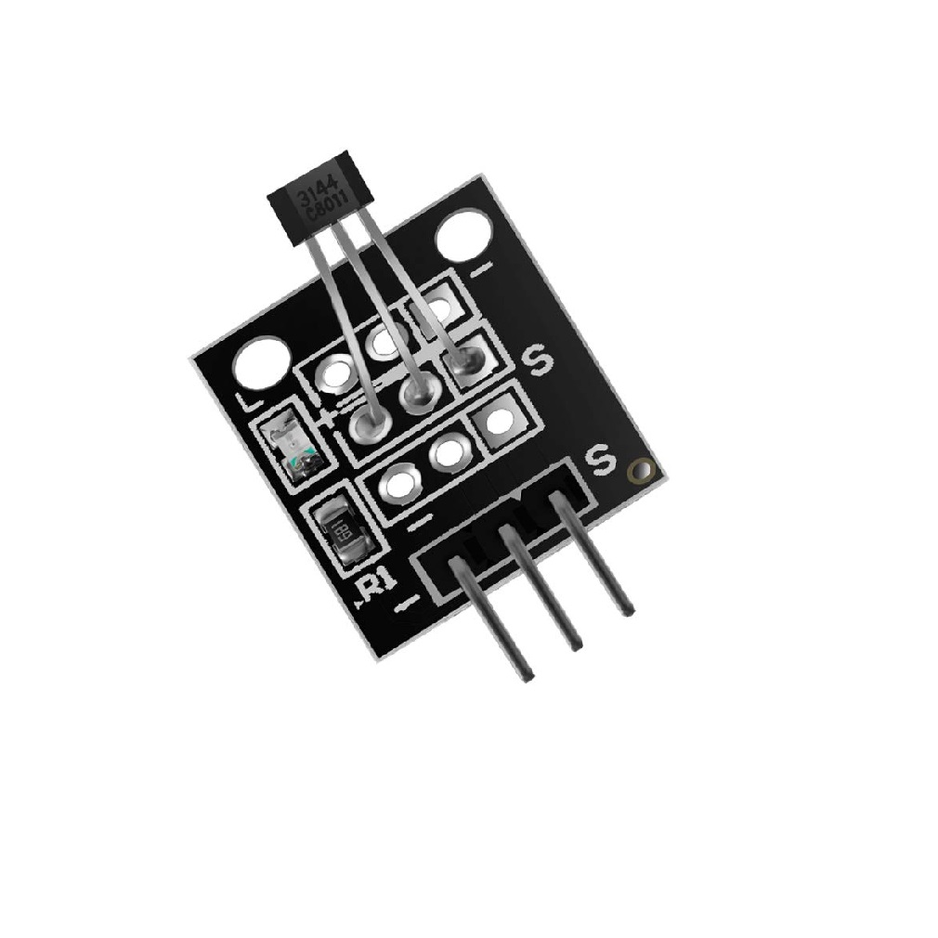

Applications:

* Automotive ignition systems
* Current sensing
* Tachometers (speed measurement)

Types:

* Linear Hall Sensors (analog output)
* Threshold Hall Sensors (digital output)

## IMU (Inertial Measurement Unit)

An Inertial Measurement Unit (IMU) is an electronic device that measures and reports a body's specific force, angular rate, and sometimes the magnetic field surrounding the body, using a combination of accelerometers, gyroscopes, and sometimes magnetometers. IMUs are central to the navigation and control of many systems, including drones, spacecraft, and smartphones.

Components: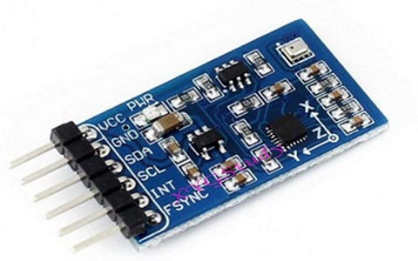

* Accelerometer → measures acceleration (m/s²).
* Gyroscope → measures angular velocity (°/s).
* Magnetometer → detects Earth’s magnetic field for heading.

Applications:

* Drones (stabilization)
* Smartphones (screen rotation)
* VR/AR systems

## Encoders

An encoder is a device that transforms motion into an electrical signal, which can then be interpreted by a control system. It offers crucial feedback regarding position, speed, or direction. Encoders are primarily categorized into two types: Incremental encoders, which generate pulses to indicate movement, and Absolute encoders, which provide a unique digital code for every specific position.

Applications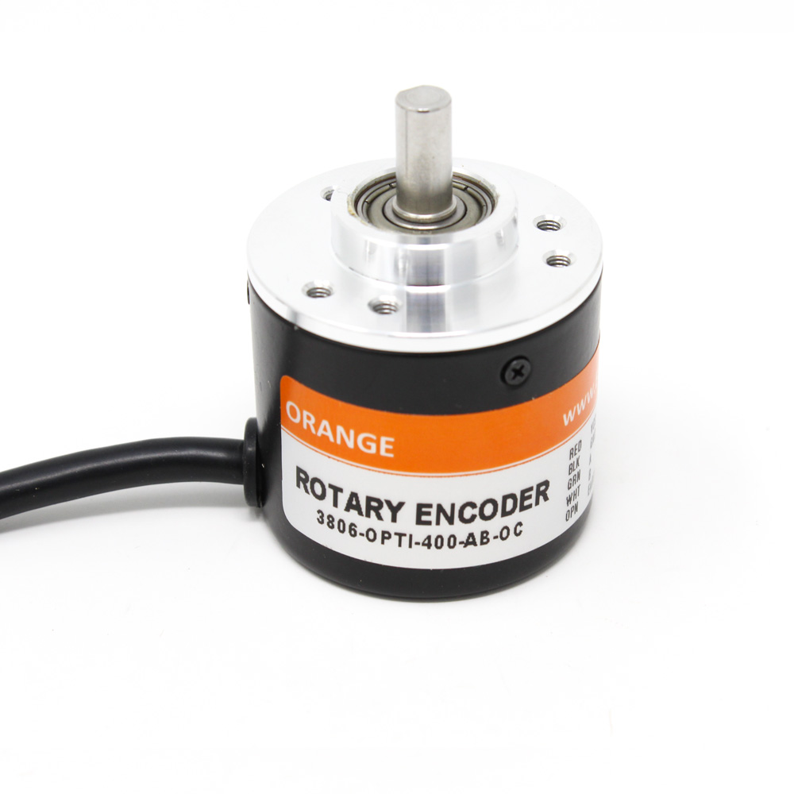

* Robotic arm joint positioning
* CNC machine tool control
* Conveyor belt speed monitoring
* Volume knobs on digital stereos

| Incremental | Absolute |
| --- | --- |
| Outputs a stream of pulses as the shaft rotates. Position is determined by counting these pulses from a known starting point. Pros:  * Lower cost * Simpler design * Higher resolution possible  Cons:  * Loses position on power loss * Requires a "homing" sequence on startup | Outputs a unique digital word for each rotational position. The position is known as soon as power is applied. Pros:  * Retains position after power loss * No homing required * Less susceptible to electrical noise  Cons:  * Higher cost * More complex wiring and electronics |

## Additional Sensors

1. Temperature and Humidity Sensors

* DHT11 and DHT22 sensors measure temperature and relative humidity.
* They combine a capacitive humidity sensor with a thermistor.
* An internal chip converts analog signals to digital.
* They provide both temperature and humidity data in a digital output.
* This digital output simplifies connection to microcontrollers.

Applications: HVAC, process monitoring, automotive cooling.

2. Gas sensors

* Their sensing material changes electrical resistance when exposed to specific gases.
* An internal heating element is needed to achieve the optimal operating temperature.
* Different MQ sensors are specialized for particular gases.
* Examples include the MQ-2 for smoke and LPG, and the MQ-135 for general air quality.

Applications: Smoke alarms, air quality monitoring.

3. Sound sensors

* Sound sensors (compact microphone modules) convert sound waves into electrical signals.
* Modules include an amplifier (e.g., LM393).
* They offer two output types:
  + Analog output: Represents the sound waveform.
  + Digital output: Goes HIGH when sound level exceeds a preset threshold.

4. Pressure Sensors

* Function: Measures force per unit area in gases or liquids, converting it into an electrical signal.
* Common Types: Strain gauge, piezoelectric, and capacitive sensors.
* Applications: Tire pressure monitoring, hydraulic systems, medical devices, and smartphones.
* Advantages: High accuracy, available in compact MEMS versions.
* Limitations: Sensitivity to temperature, requiring calibration.

5. PIR Sensors (Passive Infrared sensor)

* PIR Sensor:
  + Detects motion by sensing changes in infrared radiation.
  + Utilizes a pyroelectric sensor and a Fresnel lens.
* Applications:
  + Security systems
  + Automatic lighting
  + Robotics
* Advantages:
  + Low cost
  + Low power consumption
  + Wide field of view (FOV)
* Limitations:
  + Only detects warm, moving objects.
  + Susceptible to false triggers.